LIC DESKAPP

Login Page

We will have a single login id for a family

We will display all the policies of family members together.

We will have a sign Up page for an etire family

Formv details :-

Name of head : varchar(30)

Dob:

No of family members: int

Add family member 1:

Name (1st name only):

DOB:

M

Relation: Son/Wife etc.

…

SetUP login id;

SetUp password.

Main Pages

1st page : Login or SignUp

Two buttons

DashBOard : Graphs , will design later.

poilcyCopy (policy schedule)

Will display names of all plocy with their assoicited individual’s name .

Click to view the eCopy.

premiumCalendar

(list all preimum abt all 4 of us in this tab )

it will be month wise each monthwill have cards with name of person , policy , premium amt.

Also , alongside every month total premium in that month.

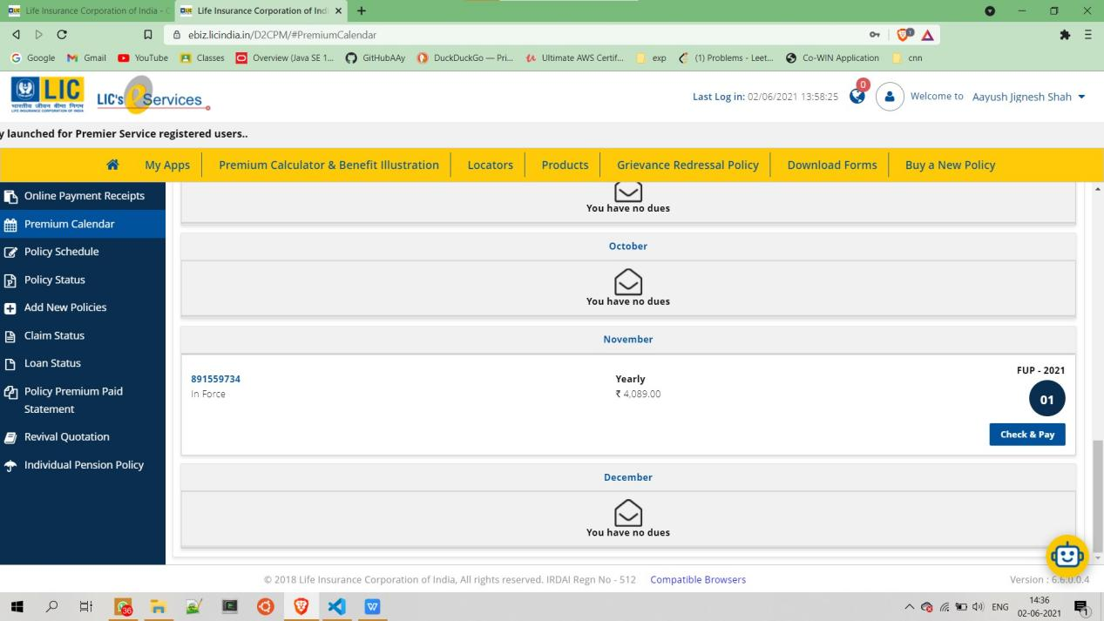

Policy status (policy info)

Will display in our own way the basic policy info and also give a link to the generated pdf.

Add new policy (Render the form to add new policy)

Also will have a button to view all the past premium paid statements

Filters for nameOfPerson , agent

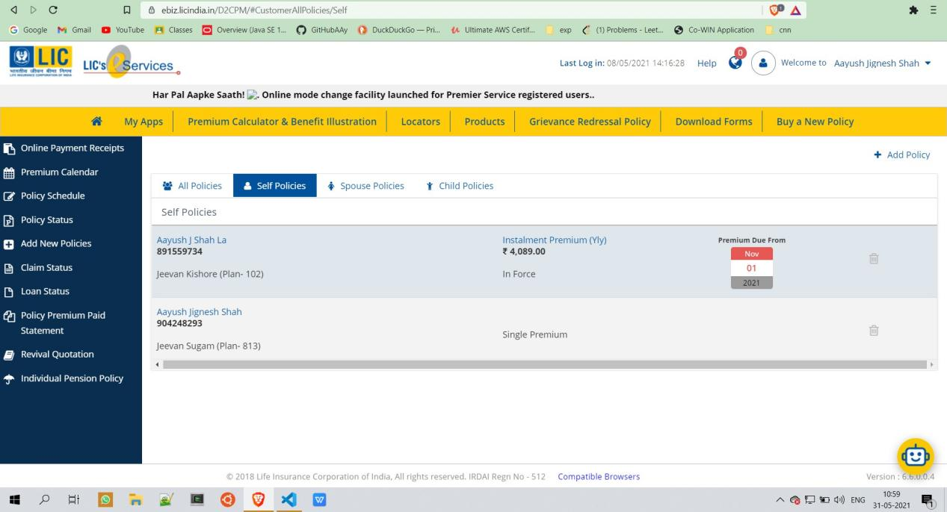

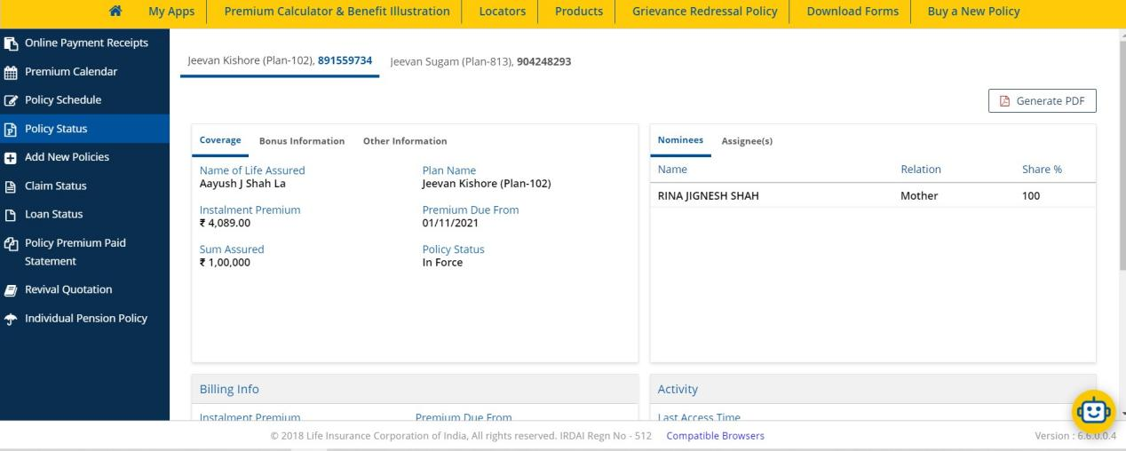

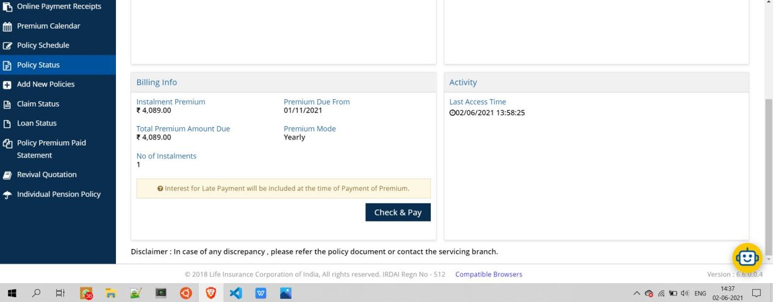

Policy premium paid statement

Filters to provide:

By year

By name (Aayush Manan) etc.

Modify messaging services

Add new Policy :

Render a form

Form Details::

Policy Holder : Dropdown with Jignesh Rina Aayush Manan as values

Insurance Type : have a drop down if not in drop down then add a new category

Policy no: varchar(30)

Policy Name : varchar(30) try to retrieve it on our own not pssble

Company : LIC , KOTAK , NEW INDIA , STAR HEALTH , SBI , add new Entry (We will render a small anoteher pane for this with initial options as buttons and a textfield to add new company)

Policy id : get name from id

Sum insured/assured : varchar(10)

First premium : Date

Premium cycle : dropDown

ONE TIME , YEARLY , HALF YEARLY , QUARTERLY , MONTHLY.

Installment premium: varchar(20)

From which A/c : BOI AAYUSH SHAH (e.g.)

Agent : Divyesh Shah varchar(30)

Nominees : Rina Shah e.g.

Agent Mobile NO : if new add else retrieve yourself

Premium month : (Or Date) varchar(30) maybe month (if available in dbms)

Last premium payment date : Date

Date of Maturity : Date

Maturity Amount : varchar(10)

No of years premium to be paid :

Notes:

Tables in DB:

Company : ICICI , KOTAK , LIC , MAX BUPA , NEW INDIA , SBI , STAR HEALTH (will be family specific) I.e. if we add a new company to this it will be only for this family .

Insurance type : same as company refer policy app on phone

Family Members

Policies

Agents :

